Current Officers, July 1, 2020-June 30, 2021
(Club Administration)
President Jim Welborne
Secretary Jenifer Wright
President Elect Cara Jones
Treasurer Jim Welborne
Past President Jessica O’Brien
Sergeant-At-Arms Matt Kubik

2019-2021 board members 2020-2022 board members
Lance Werner → Club Public Relations ← Debbie Tatum
Matt Kubik → Rotary Foundation/Fundraising ← Dennis Carroll
Jenilee Haynes-Peterson → Service Projects ← Nicole Manning
Adam Vidoni → Membership ← Terry Voltz

Topics
- Secretary Reports
  - Approval of Minutes from April
    - Motion to approve Matt, Second Lance. Secretary reports approved
  - Review of Secretary Reports
- Treasurer Reports
  - Approval of Financial Report (See Attachment 1)
    - Motion to approve Matt, Second Lance. Treasurer report approved.
  - Status of dues payments (See Attachment 2)
- Club Meetings
  - Locations for meetings starting in June
    - Discussed many options, reviewed cost of each venue. Shoreline, Zorn, Friendship Gardens, city parks. Up to June 3 is covered. Future meetings TBD
- County Immunization Day (See Attachment 3)
- Jennifer to make a list of what rotary can do to help with vaccines and get it to Jim for Back to School
- Presidential Citation Goals’ Action Plans Status
  - Review Board Member Commitments (See Attachment 4)
  - Membership (Adam Vidoni, Terry Voltz)
    - District training
    - Retention calls
  - Club Public Relations (Lance Werner, Debbie Tatum)
    - Member profiles
  - Rotary Foundation/Fundraising (Matt Kubik, Dennis Carroll)
  - Service Projects (Nicole Manning, Jenilee Haynes-Peterson)
    - Scholarships
    - Apple Dumpling
    - Rotary Garden
  - Administration (Cara Jones, Jessica O’Brien)
    - Strategic Planning
    - Board member and officer election
Old business
  - Rotaract Club at Purdue University Northwest
- New business
  - Discussion of 13 ways to kill your Rotary Club video

Next Board Meeting: Jun 23, 2021

Attachment 1
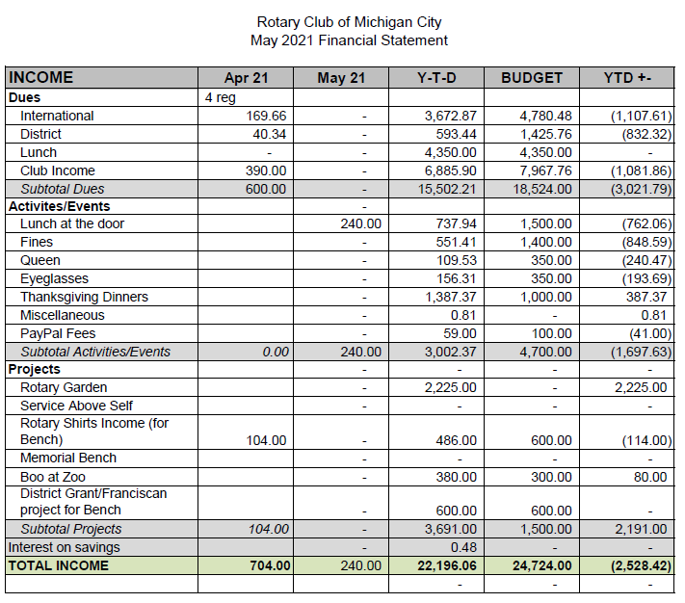

Attachment 1 (Continued)
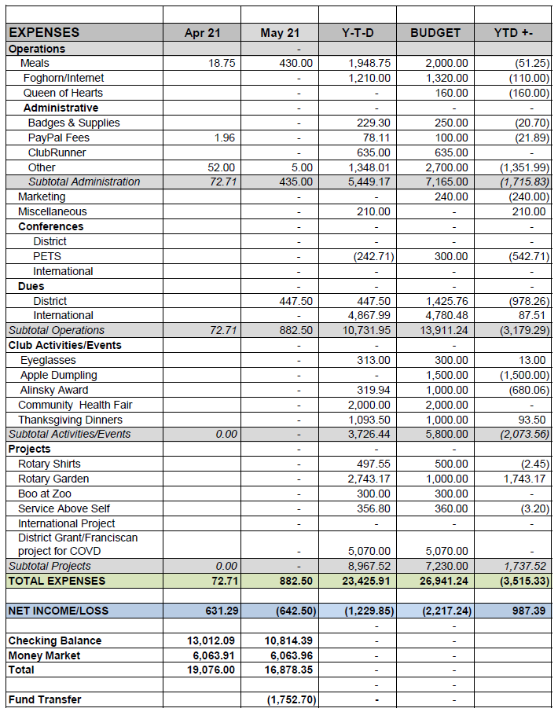
$430 Meals Expense includes $150 Garden and $100 Yacht Club Rentals, Other Expense is $5.00 check view fee
Funds transferred include $1,552.70 from PayPal to RCMCF and $200 from PayPal to Rotary Foundation
Attachment 2

Unpaid dues as of March 21, 2021

Name | Balance
Donoghue, Patrick | $150.00
Krause, Julia | $205.00
May, Abby | $300.00
Neff, James D. | $150.00
Smith DDS, Bruce | $300.00
Voltz, Terry | $150.00
 | $2,605.00

Attachment 3
- Planning
  - Dates and locations
  - Promotion
    - Radio
    - Paper
    - Social Media
    - Websites
  - Develop and staff teams
    - Drivers
    - Recruiters
    - Providers
    - Clerical
    - Couriers
    - Management
  - Document procedures
  - Gather supplies
- Execution
  - Assemble at designated location
  - Pickup supplies
    - Vaccination Cards
    - Vaccination logs
    - Clip Boards
    - Tables
    - Vaccination supplies
      - Vaccine
      - Syringes
      - Swabs
      - Band aids
      - Disposal containers
    - Neighborhood Maps
    - Patient information sheets
  - Travel to immunization location
  - Setup inoculation site
    - Registration desk
    - Inoculation tables
    - After shot waiting area
  - Send out recruiters/drivers

Attachment 3 (Continued)
  - Administer inoculations
    - Register patients
      - Fill out log
      - Fill out Vaccination Cards
      - Escort patient to inoculation table
      - Leave vaccination card with provider
    - Inoculate patients – give patient vaccination card
    - Send patient to after shot waiting area
  - If more vaccine is needed
    - Provider notifies Courier
    - Courier packs vaccine into cooler with dry ice
    - Courier takes vaccine to inoculation location
  - Wrap-up
    - Gather trash and used syringes
    - Pack up supplies
    - Give logs and any remaining vaccine to provider

Attachment 4
Jun:
Since strategic planning will concentrate on the future of our club it was thought that the President Elect should head the committee utilizing new, established and senior members.
Jul:
Board Members will work on action plans and have ready for next meeting.
Aug:
Board members currently working on list to call members and invite to next meeting.
Board to start thinking on other ways to reach out to members to attend.
Sep:
Retention requires board action-Board Members should contact club members who have not renewed and encourage them to renew (see attached).
28 members have not paid dues. Jim to send a list out to board to call.
Committee Commitments:
Membership
- Our club will have at least 60 new members by end of year
- Club will organize and support 1 Interact or Early Act club during rotary year
Public Relations
- Clubs online presence accurately reflects current activities
- Social media accounts will be updated 4 times/month
- 4 media stories will be covered during the Rotary year
- The club will use Rotary International advertising and public service materials such as broadcast videos, print ads, and other official materials
Rotary Foundation/Fundraising
- $3000 will be contributed to the Rotary Foundation Annual Fund by club and its members during the Rotary year
- $500 will be contributed to the Rotary Foundation PolioPlus Fund by our club and its members during the Rotary year.
Service Projects
- At least 48 members will participate in club service activities during the Rotary year
- 2 club members will be members of Rotary Fellowship during the Rotary year
- Club will complete 5 service projects
- Club will sponsor 4 individuals in RYLA
- 6 social activities will be held outside of regular meetings during the rotary year
Administration
- Our club will have an up-to-date strategic plan
- Jessica O’Brien to send out strategic plan to board
- 4 of our club’s committee chairs will attend one of the district training assemblies
Club Foundation Projects
- Ivy Tech Scholarship
- Club Scholarship
- RYLA-3-6 students needed. Deb V. to see if participation will be available through MCAS
Oct:
- Need a volunteer to take on the Club Scholarship.

Nov:
- Terry to put together LinkedIn account
- Terry to inquire about Rotary license plates through the BMV
- Need for project budgets
Dec:
- There is a candidate from Ill who works in MC and is interested in joining. She’s been invited to 1/7/21 meeting.
- Terry will work with Lee Morris on a group get together to see what membership ideas he has.
- Matt needs to come up with a fundraiser for online this spring. i.e. Gala or paid event. Online concert suggested.
- Matt will call the district to see if there are any suggestions for fundraising that was successful in the past.
- Matt will contact Chef Erik/cooking show fundraiser split for soup kitchen and Rotary
- Elections February 3, 2021
Jan:
- Goal is to raise $3000 for the Foundation Matt will present to club at next meeting. Requirement for future District Grants.
- Jim will get copy of scholarship application to Jenilee and meet together to discuss.
- Jenilee to form a scholarship committee. Jessica O’brien agreed to be part of the committee
- Board and officer elections: Cara to send list of selected officers to Jim. Elections start beginning of February. Cara and Jim to meet to discuss elections.
- Rotaract Club at Purdue University Northwest: Jim is looking into doing this
- Deb Varnek is stepping down. Board is now looking for new treasurer for the club. Contact Jim if anyone wants to take this on or if we know anyone that would be interested.
Feb:
- Board to sign-up for table host. Seeking a minimum of 3 board members per meeting
- Jim is contacting Dean of the School of Business at Purdue Northwest for speakers
- Jim will contact Assistant District Governor regarding membership recruitment.
- Nicole will be meeting with Jenilee to discuss Apple Dumpling and Scholarships. Jim suggested contacting La Porte Club for how they find projects.
- Board member and officer election: Cara missing one person. Should be ready by next meeting.
- 3/11 to 3/13 online PETS to be attended by Cara and Jenilee.
Mar:

